The City School – Educational Technology Department

Aims+ User Manual

For Teacher Guidance

Contents

Introduction 2

Advantages of Aims+ 2

Overview 3

Performance Evaluation 4

Student Subject Wise 4

Student Wise 5

Practical Marks 6

Class Wise 6

Student Wise 7

Activity Wise 7

Exam / Course Work 9

Subject Wise 9

Evaluation Type Wise 10

Evaluation Criteria Wise 11

Schedule Test 12

Schedule Test 12

Term Attendance & Comments 13

Term Attendance & Comments 13

First Term Attendance 14

First Term Attendance 14

View Marks 15

View Marks (Subject Wise) 15

Teacher Acknowledgement 16

Welcome Letter 16

Teacher Acknowledgement 17

Marks Compilation 17

TCS Reports 18

Teacher reports 18

Search 18

Schedule Test Attendance 20

Schedule Test Attendance 20

Progress Checker 21

Progress Checker 21

# Introduction

AIMS+ is an advanced version of idealAims to manage student data. Academic management Information System (Aims+) provide capabilities for entering student test and other assessment scores, build student schedules, track student attendance, and manage many other student-related data required in a school.

## Advantages of Aims+

* Aims+ Management System turns your manual means of results into digital form over an online hosting platform.
* Archives your school results from the very date you start using it.
* Automatically computes cumulative scores and grades according to figures being keyed in.
* Helps you to call-up a particular student’s result at any point in time.
* Rates your school higher than your competitors.
* Reduces the rate of human errors. E.g. Mis-calculation of cumulative scores.
* Automatically awards remarks to student based on grades.
* Parents and guardians can have access to their ward’s results/performance is school. This helps to put such a student in check.



# Overview

1. Performance Evaluation
2. Practical Marks
3. Exam / Course
4. Schedule Test
5. Term Attendance and Comments
6. First Term Attendance

These main menus contain multiple sub menus to facilitate the teacher to enter the student result smoothly.

1. Performance Evaluation

There are two different ways to enter student performance grading and evaluation

* Student Subject wise

(To enter marks student and subject wise)

* Student Wise

(To enter marks student wise for all subject)

1. Practical Marks

There are three different ways to enter student practical marks

* Class Wise

(Practical marks entry of whole class for one activity)

* Student Wise

(Practical marks entry of single student’s all activity skills)

* Activity Wise

(Practical marks entry of all class students for one activity skill)

1. Exam / Course

There are three different ways to enter student exam/course work marks

* Subject Wise

(Exam and course work marks entry of whole class for one subject)

* Evaluation Type Wise

(Exam and course work marks entry of whole class for each Evaluation Type (i.e. Exam or course work))

* Evaluation Criteria Wise

(Exam and course work marks entry of whole class for each Evaluation Criteria of Evaluation Type (i.e. Class work / Schedule Test))

1. Schedule Test
2. Term Attendance and Comments
3. First Term Attendance

# Performance Evaluation

## Student Subject Wise

(To enter marks student and subject wise)

To enter student’s all subject grading from one screen

Marks Entry 🡪 Performance evaluation 🡪Student Subject Wise

1. Click on the **Mark Entry** than **Performance Evaluation** and then click **Student Subject Wise**.
2. In this section teacher can enter the student’s Marks Subject wise.

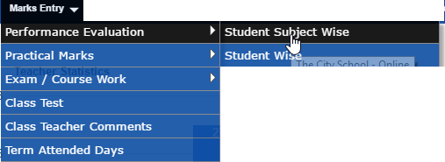

1. 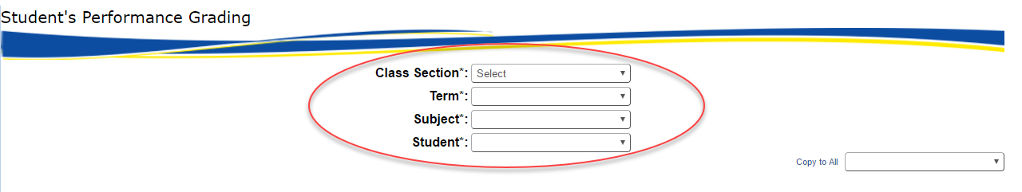Select criteria as mentioned in below picture that is highlighted in Red Color.

Teacher will select

Class Section🡪Term🡪Subject and Student

4. Then the Performance Activity keys will show in grid and teacher will assign the Achievement Ratings to the students as mentioned in Green color highlighted area. Enter all other relevant information that is shown in given screen shot then press save

5. If the student is promoted than tick the check box which is highlighted in black and then press the save button .Grades of all subjects will be assigned to a single Student.

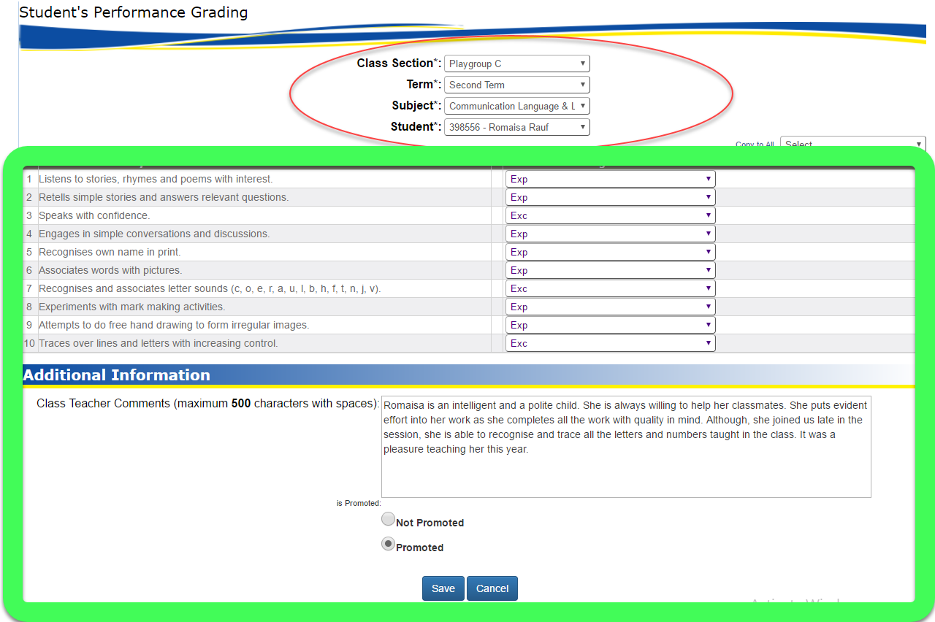

Note:

* Assign to all dropdown is helpful to enter criteria directly to all records instead of selecting one by one record

## Student Wise

(To enter marks student wise for all subject)

Marks Entry 🡪 Performance evaluation 🡪Student Wise

Click on the **Mark Entry** then **Performance Evaluation** and then click **Student Wise**.

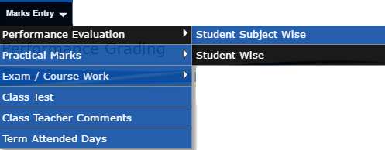

1. After selecting the criteria as mentioned in the image above.

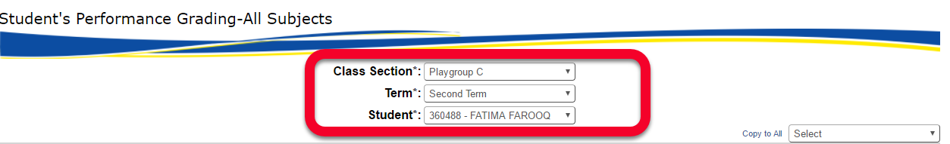

Teacher will select

Class section🡪Term and Student

1. Complete list of all subjects with performance activity for selected student will appear. After selecting the grades according to subjects highlighted in red area. Click the button Save.

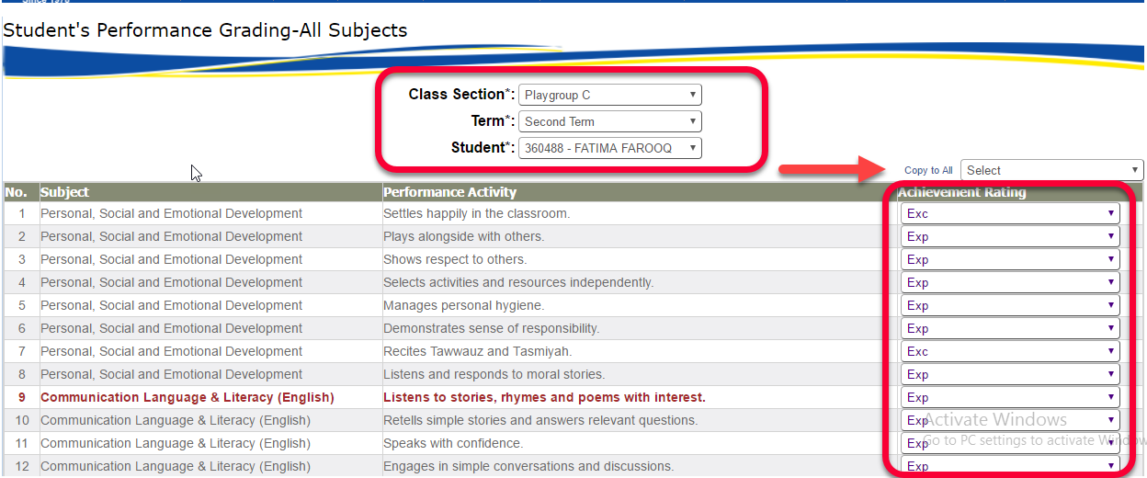

# Practical Marks

## Class Wise

(Practical marks entry of whole class for one activity)

Marks Entry 🡪 Practical Marks 🡪Class Wise

To Enter Student Practical Marks Class Wise. Click on the **Mark Entry** then **Practical Marks** and then click **Class Wise**.

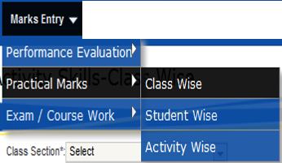

Now Teacher can select desired activity using highlighted dropdown.

Class Section 🡪 Subject 🡪 Term and Activity

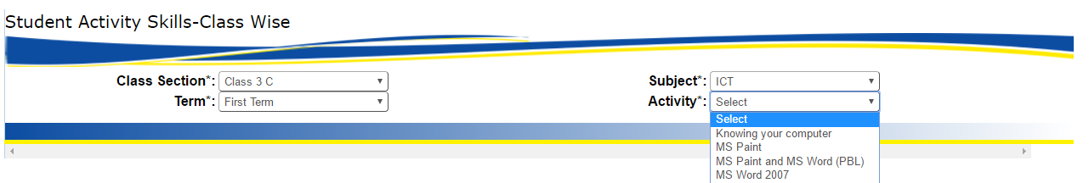

2. All the students of that class will appear in columns and activity skills as rows .Use vertical or horizontal scroll to enter marks of all students. Enter all the marks and then press save button.

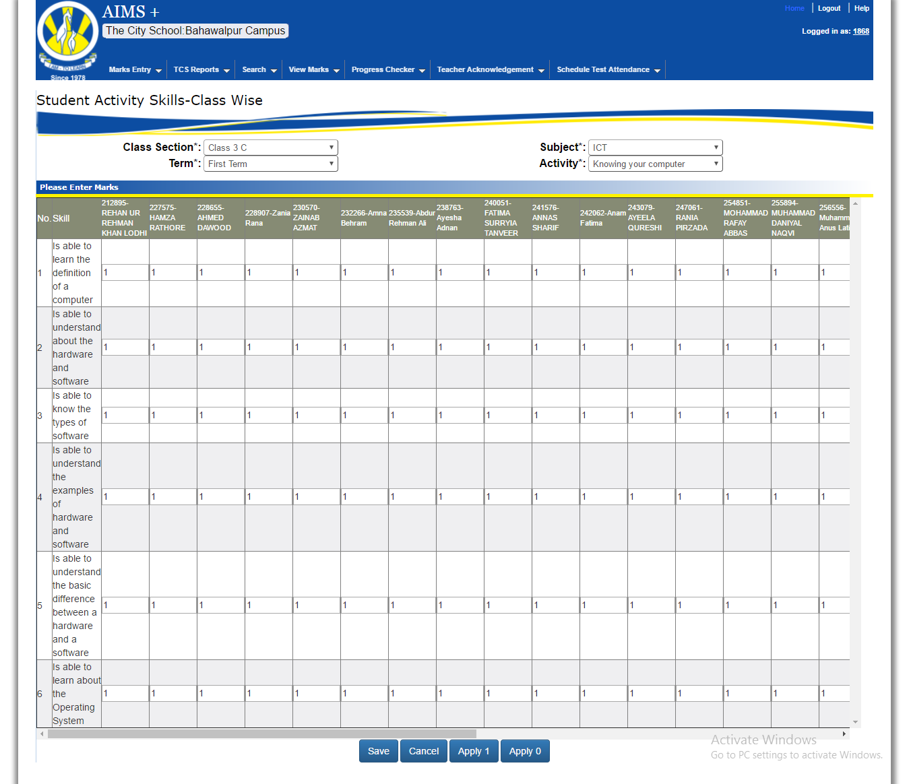

Click on Apply 1 or Apply 0 to enter all student’s marks at once.

## Student Wise

(Practical marks entry of single student’s all activity skills)

Marks Entry 🡪 Practical Marks 🡪Student Wise

Now using this screen can enter the record student wise. Click on the **Mark Entry** then **Practical Marks** and then click **Student Wise**.

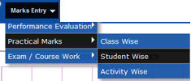

Teacher can select

Class Section 🡪 Subject 🡪 Student and Term

1. After selecting the criteria shown in given image. All the category of practical will be shown .Enter the marks and click the save. As well as teacher can apply 1 or 0 to all students by clicking apply 1 or apply 0 buttons

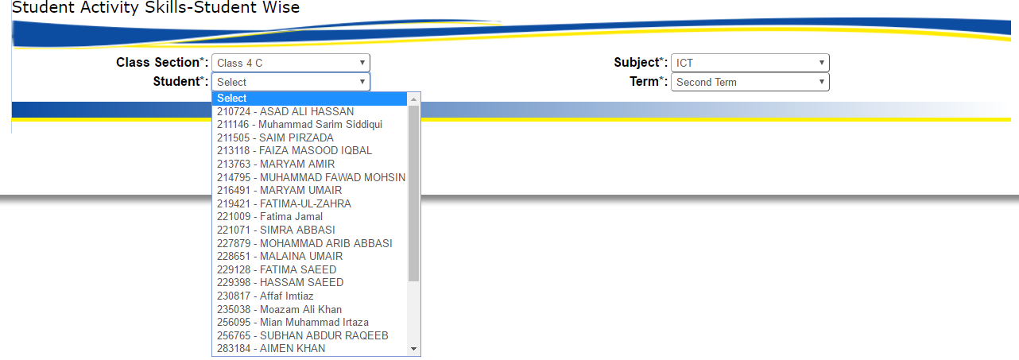

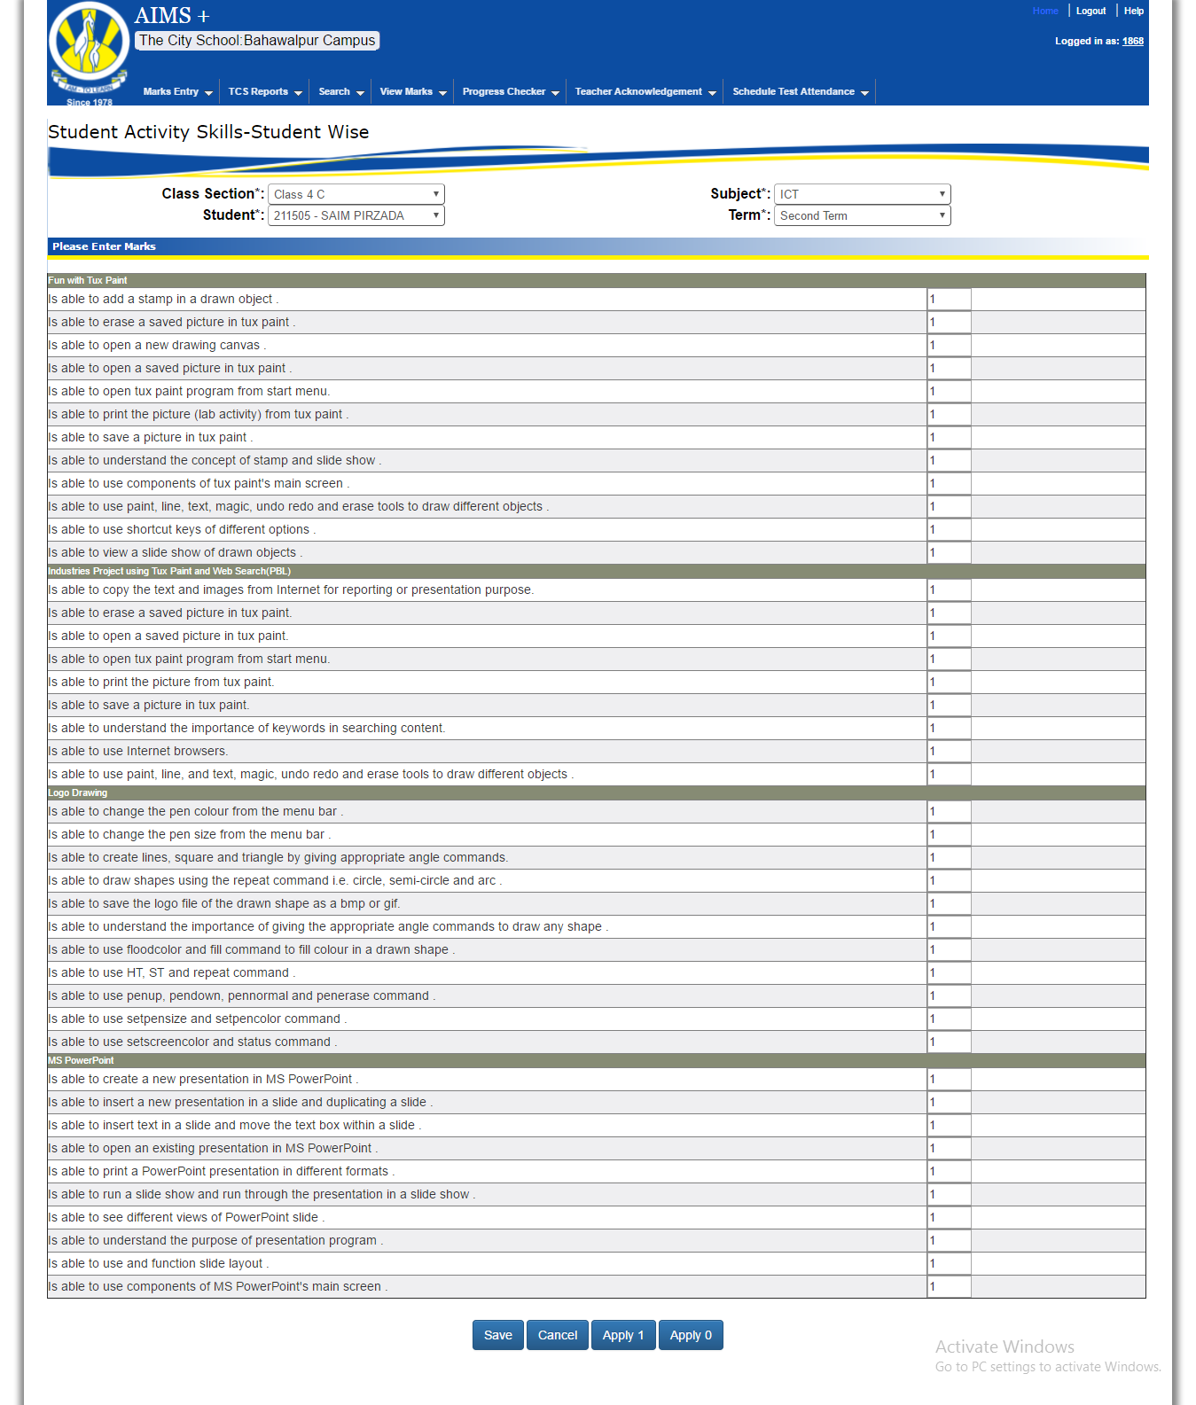

## Activity Wise

(Practical marks entry of whole class for one activity skill)

Marks Entry 🡪 Practical Marks 🡪Activity Wise

Using this screen teacher can enter result of all student by selecting the desired activity. Click on the **Mark Entry** then **Practical Marks** and then click **Activity Wise**.

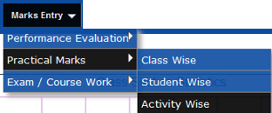

1. In the given picture you can see a new drop down list named Skill. With the help of it teacher can enter the marks skill wise

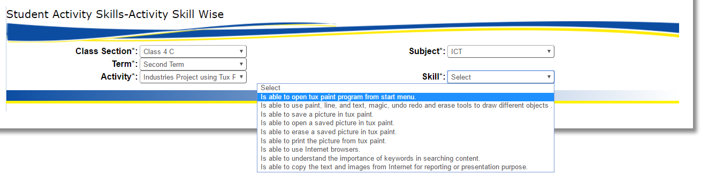

Teacher can select

Class Section🡪Subject🡪Term🡪Activity and Skill

1. After selecting the skill you can see all the students of the relevant class. Now you are able to see all the students and can enter Students marks. After entering the marks click save button.

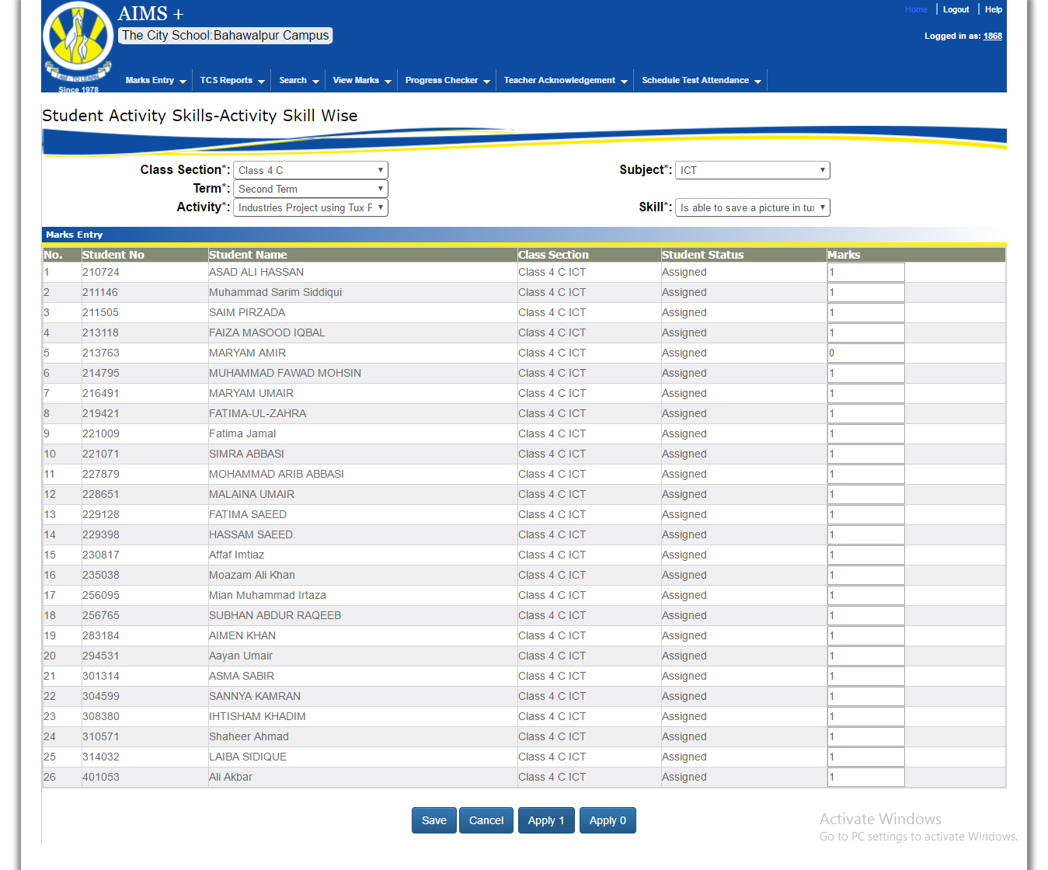

3. You can select Activity and then skill. After that repeat the step mentioned in above Image.

Click on apply 1 or apply 0 to enter of all student’s marks at once and teacher can enter data of multiple activities and skills according to the requirements.

# Exam / Course Work

Our next Step is to enter the Exam/Course Work. There are three different ways to enter student exam/course work marks

## Subject Wise

(Exam and course work marks entry of whole class for one subject)

Marks Entry 🡪 Exam/Course Work 🡪Subject Wise

Using this screen teacher can enter the student‘s Exam / Course work marks subject wise. Click on the **Mark Entry** than **Exams /Course Work** and then click **Subject Wise**.

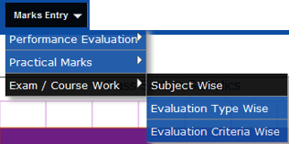

1. If a particular student is not selected then all students of that section will appear at once.
2. But we can enter the marks of a single students which will be discussed in the next image.

In this screen teacher can select

Class Section🡪Subject🡪Student and Term

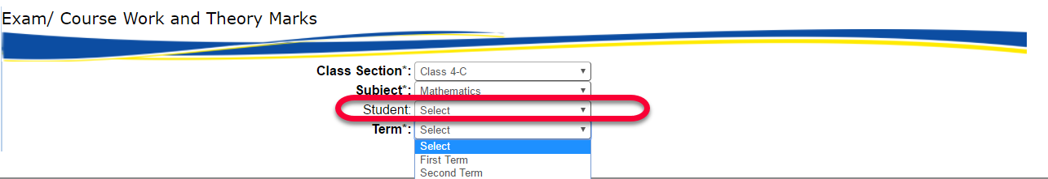

After selecting all values data will show in grid for like picture below

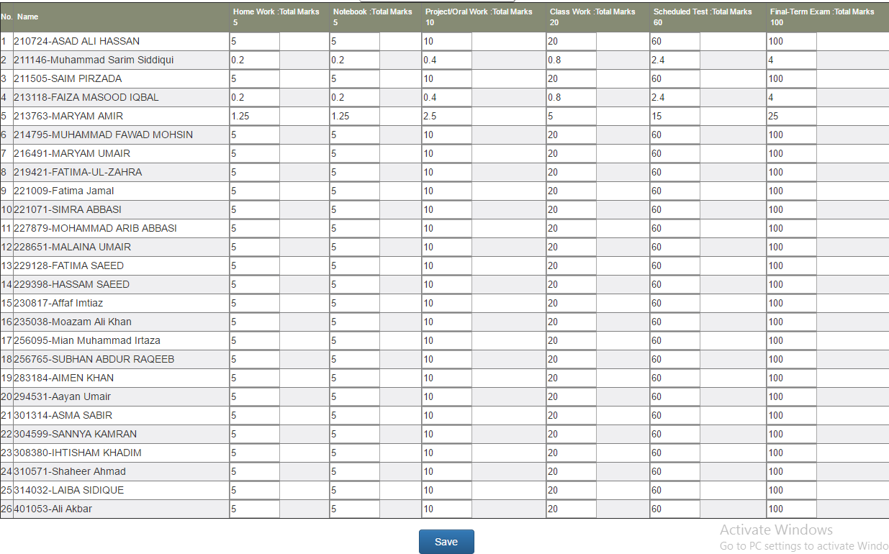

1. To enter the Exam/Course Work and Theory Marks for a single student you just need to select the student shown below in the image.

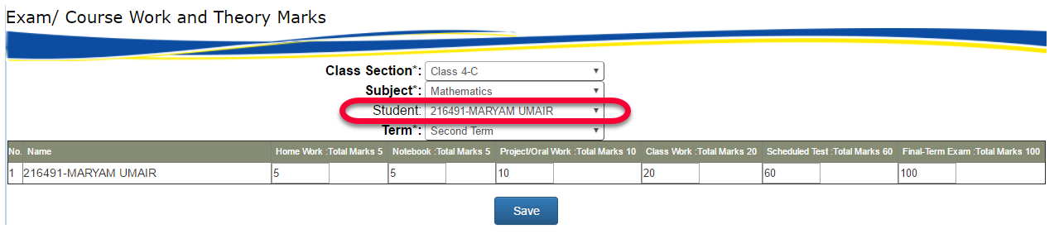

Using this screen teacher can enter data of individual student or selecting one by one.

## Evaluation Type Wise

(Exam and course work marks entry of all class students for each Evaluation Type (i.e. Exam or course work))Next Step to enter the Exam/Course Work and Theory Marks Evaluation Type Wise. Click on the **Mark Entry** than **Exams /Course Work** and then click **Evaluation Type Wise**.

Marks Entry 🡪 Exam/Course Work 🡪Evaluation Type Wise

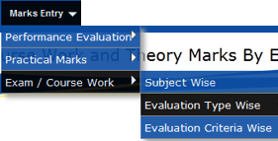

1. In this section teacher can enter data on the basis of Evaluation Type. After selection the all criteria same as above you have to select Evaluation type. We got two types of evaluation’s Type (Course Work / Exam Theory)

Teacher can select

Class Section🡪Subject🡪Student🡪Term and Evaluation Type



Evaluation Type based on Course work and exams theory marks.

1. Marks can be entered for individual student and for a whole section.

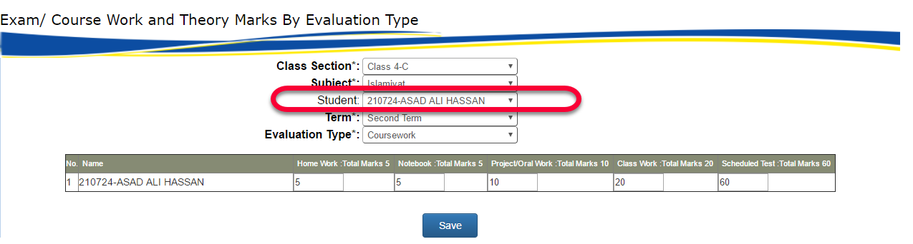

## Evaluation Criteria Wise

(Exam and course work marks entry of all class students for each Evaluation Criteria of Evaluation Type (i.e. Class work / Schedule Test))

1. In this step teacher can enter the Marks Evaluation Criteria Wise.
2. Click on the **Mark Entry** than **Exams /Course Work** and then click **Evaluation Criteria Wise**.

Marks Entry 🡪 Exam/Course Work 🡪Evaluation Criteria Wise

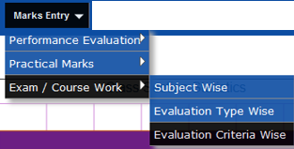

In this step you can see Evaluation criteria.

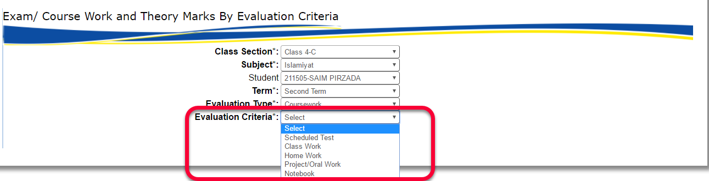

Teacher can select

Class Section🡪Subject🡪Student🡪Term🡪Evaluation Type and Evaluation Criteria

1. After Selecting the Evaluation Criteria you can see only one student. But if you want to enter the marks of all students at once you don’t need to select a student.



# Schedule Test

## Schedule Test

(To enter schedule test marks)

To enter student’s all subject schedule marks from one screen

Marks Entry 🡪 Schedule Test

1. Click on the **Mark Entry** than **Schedule Test**.
2. In this section teacher can enter the student’s Marks of schedule test.

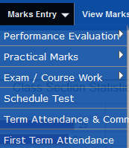

Teacher can enter multiple or single entry of student schedule test marks

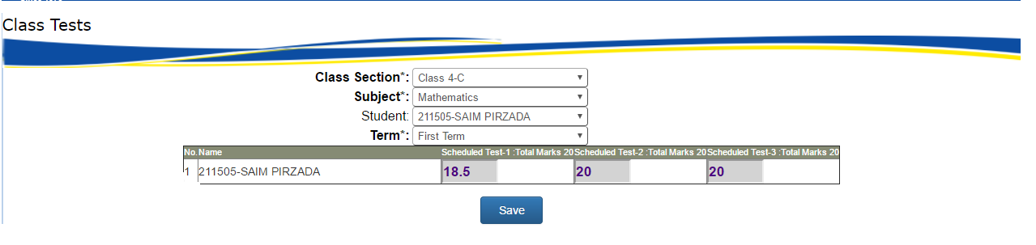

For multiple entry

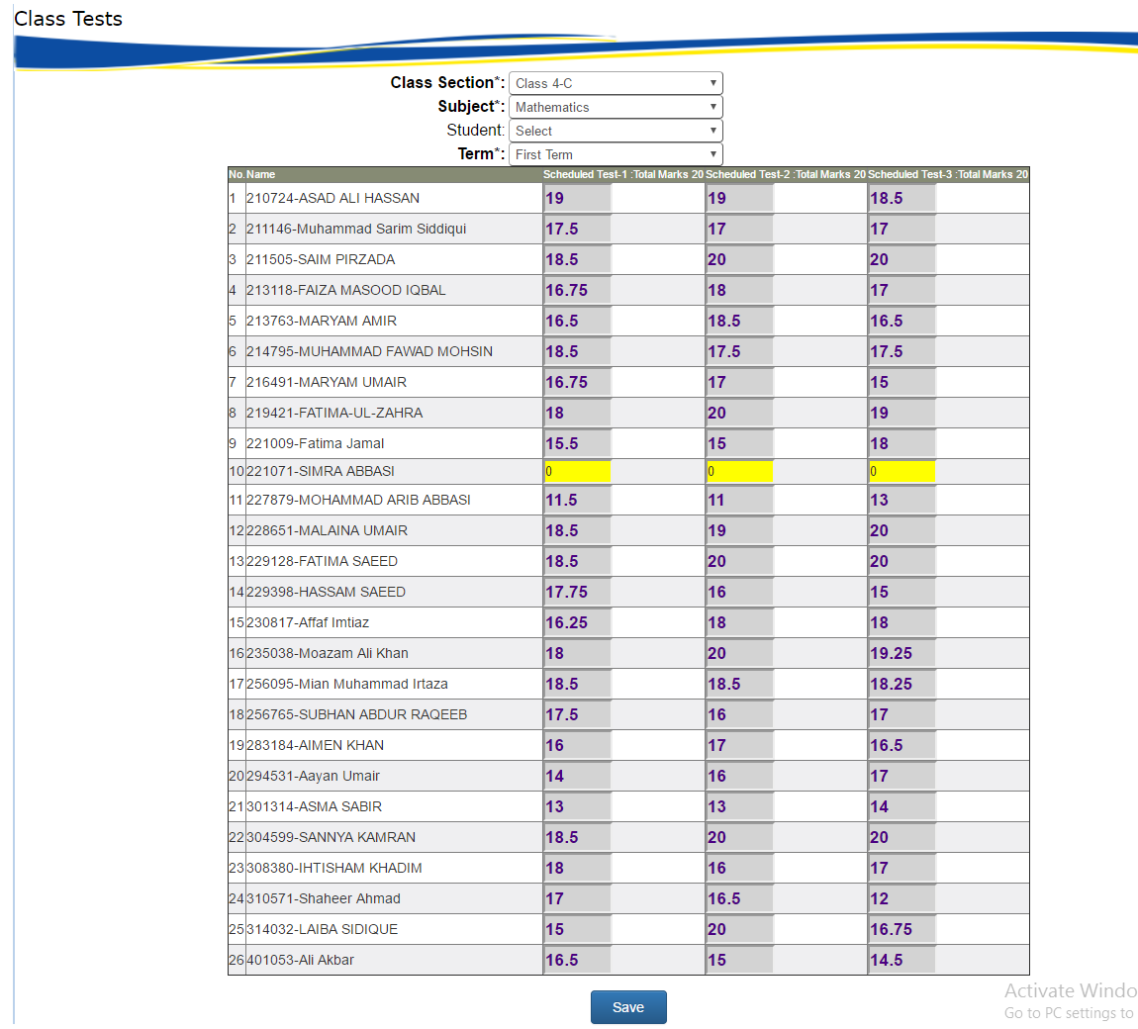

# Term Attendance & Comments

## Term Attendance & Comments

(To enter total day attend of student and comment)

Marks Entry 🡪 Term Attendance & Comments

1. Click on the **Mark Entry** than **Term Attendance & Comments**.
2. In this section teacher can enter the student’s attendance (total days attend) and his comments.



Teacher can enter student total days attend and comments on

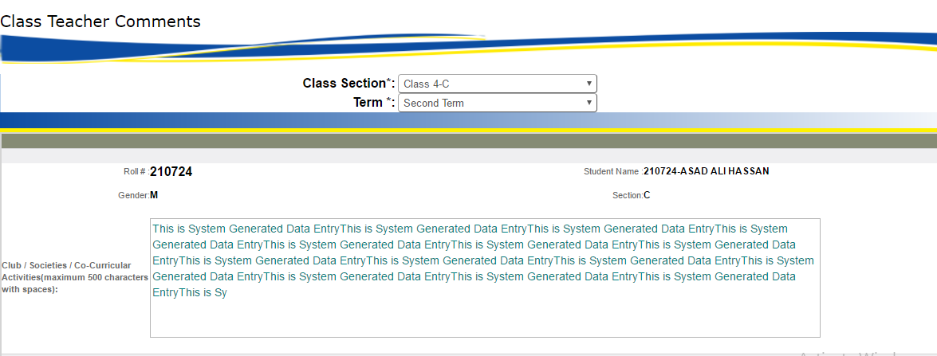

# First Term Attendance

## First Term Attendance

(To enter total day attend of student and comment)

Marks Entry 🡪 Term Attendance & Comments

1. Click on the **Mark Entry** than **First** **Term Attendance**.
2. In this section teacher can enter the student’s attendance (total days attend) of first term.

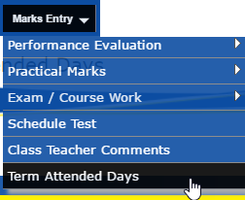

In this section teacher can add total attend days of student of class section wise

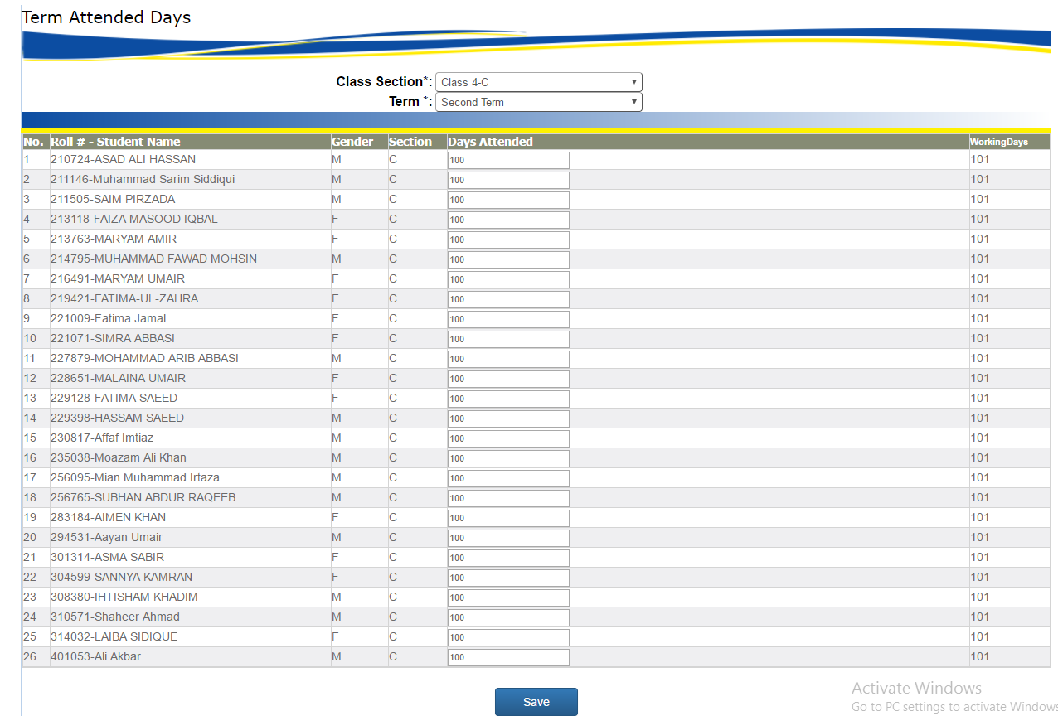

# View Marks

## View Marks (Subject Wise)

(To view student marks subject wise)

View Marks 🡪 Subject Wise

1. Click on the **View marks** than **Subject Wise**.
2. In this section teacher can view marks of students class section, subject, session and term wise.

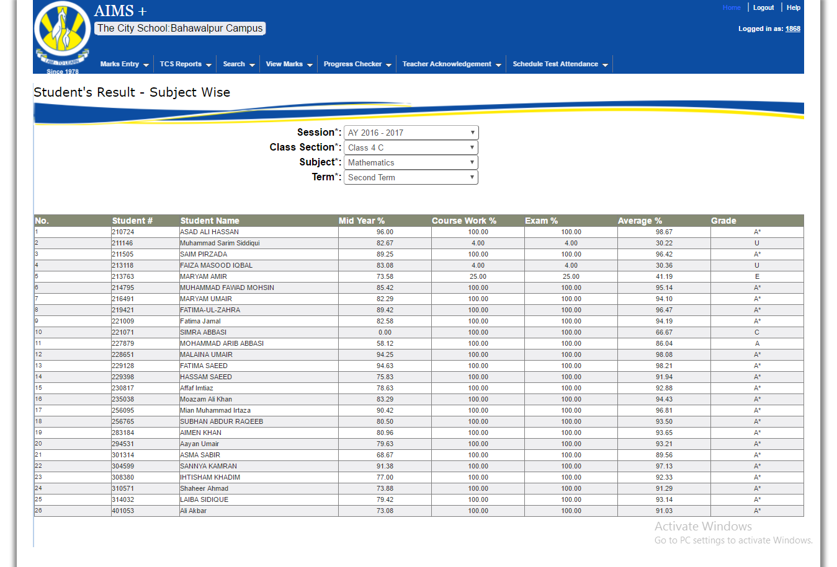

# Teacher Acknowledgement

## Welcome Letter

(To generate welcome letter)

Teacher Acknowledgement 🡪 Welcome Letter

1. Click on the **Teacher Acknowledgement** than **Welcome Letter**.
2. In this section teacher can enter generate welcome letters for students.

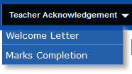

In this section teacher can generate the welcome letters of desired class us toggle check option then system automatically welcome letter of desired class.

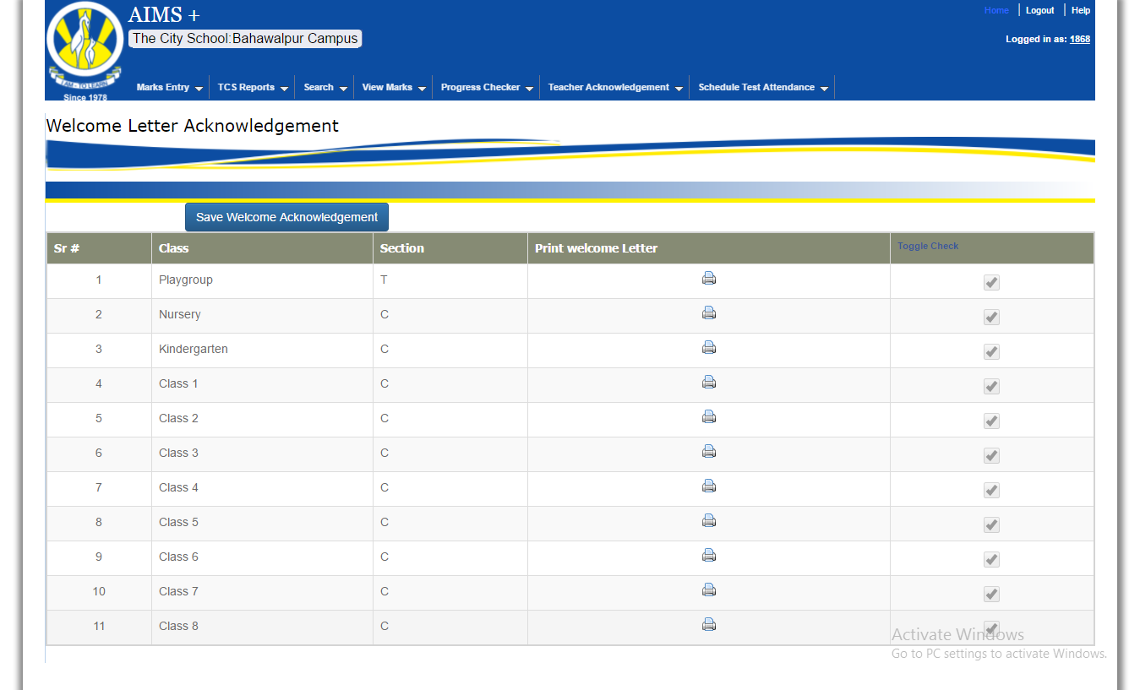

# Teacher Acknowledgement

## Marks Compilation

(To complete marks of student for result process)

Teacher Acknowledgement 🡪 Marks Completion

1. Click on the **Teacher Acknowledgement** than **Marks Compilation**.
2. In this section teacher can complete the status of marks for students.



This section useful to show the complete or UN complete the marks acknowledgement

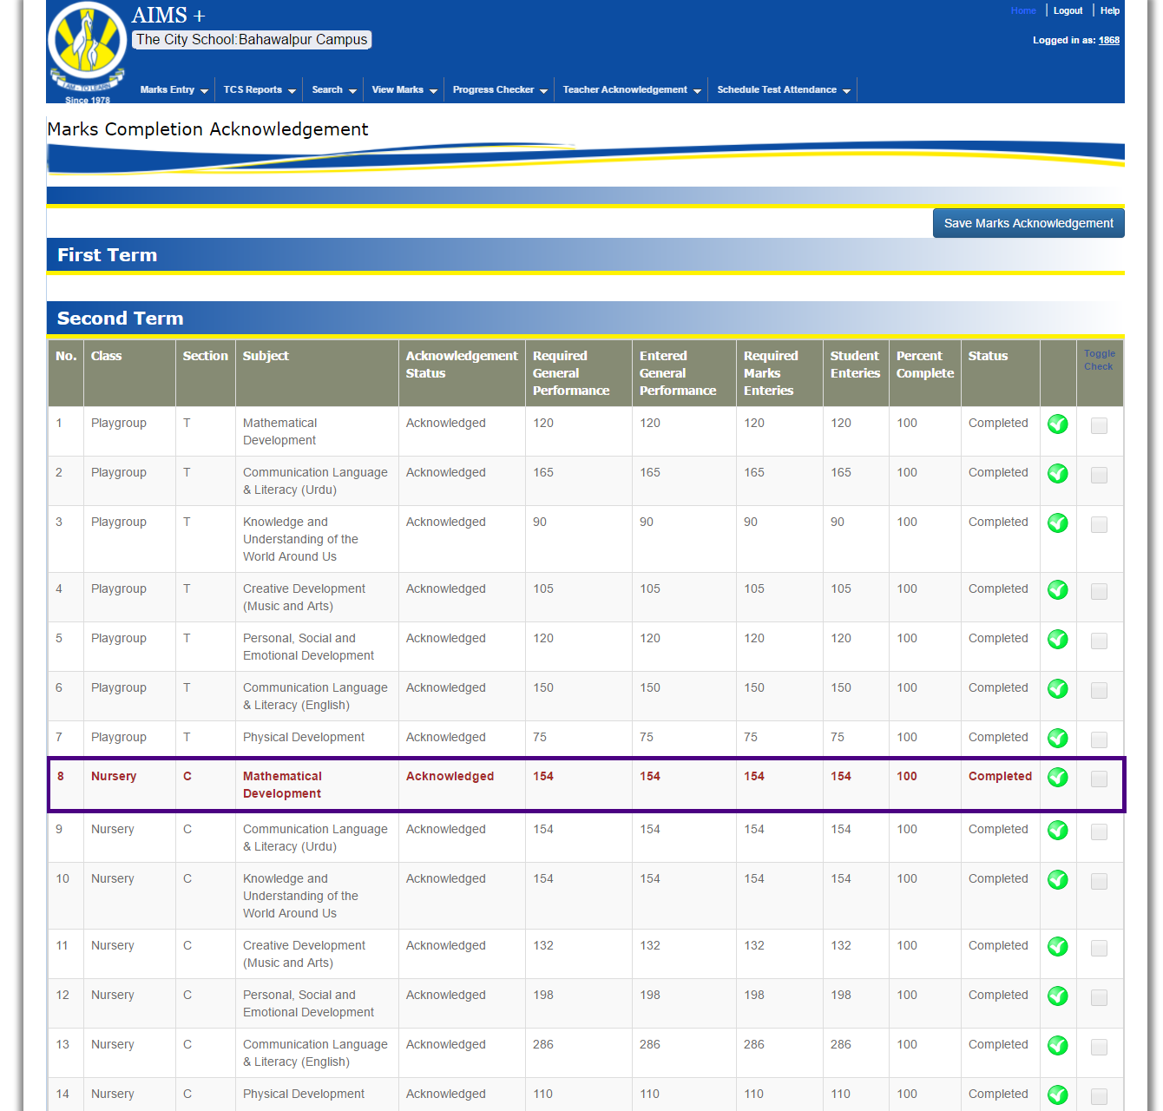

# TCS Reports

## Teacher reports



TCS Reports🡪 Teacher Reports🡪Marks Checking

Contains these reports

* Student performance Entry Sheet
* Course work Entry sheet
* Practical Marks Entry sheet

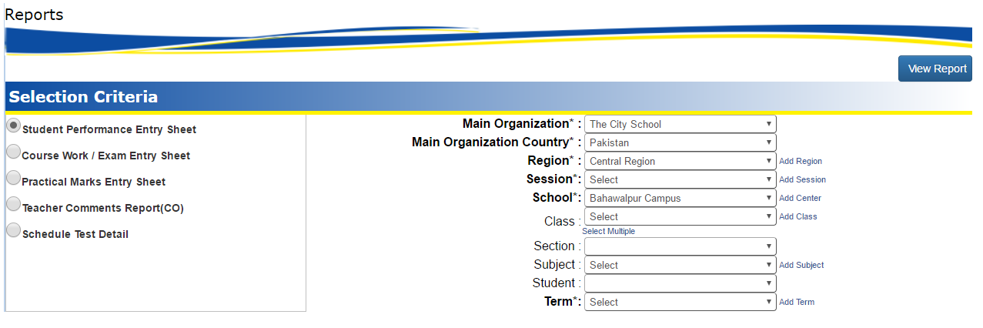

And teacher can select report by following criteria filters

Main Organization🡪Main Organization🡪 Country🡪Region🡪Center🡪Session🡪Class🡪Section🡪Subject🡪Student and Term

# Search

This system provides facility to search following categories

Search 🡪 Search Student

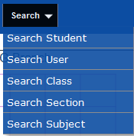

* Search Student
* Search User
* Search Class
* Search Section
* Search Subjects

Teacher can search desired information by given screen. These screens contains some filters like

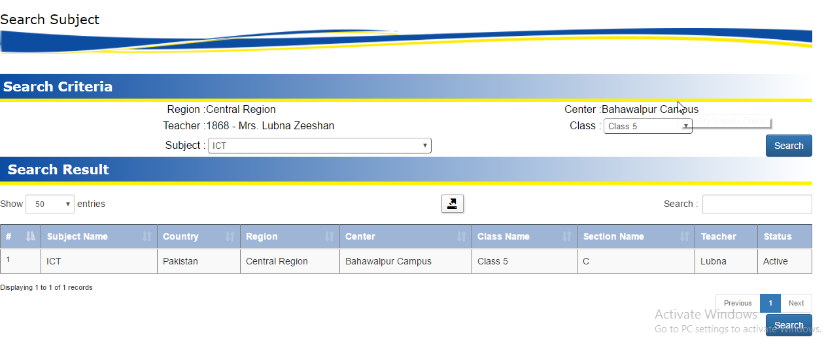

The desired result shown in grid form

# Schedule Test Attendance

## Schedule Test Attendance

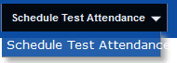

(To complete attendance of student for Schedule Test)

Schedule Test 🡪 Schedule Test

Teacher can mark schedule test attendance using this screen

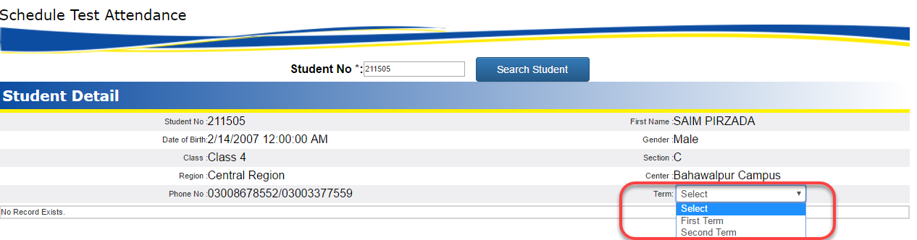

Teacher can select only relevant student and can manage schedule test attendance by term wise

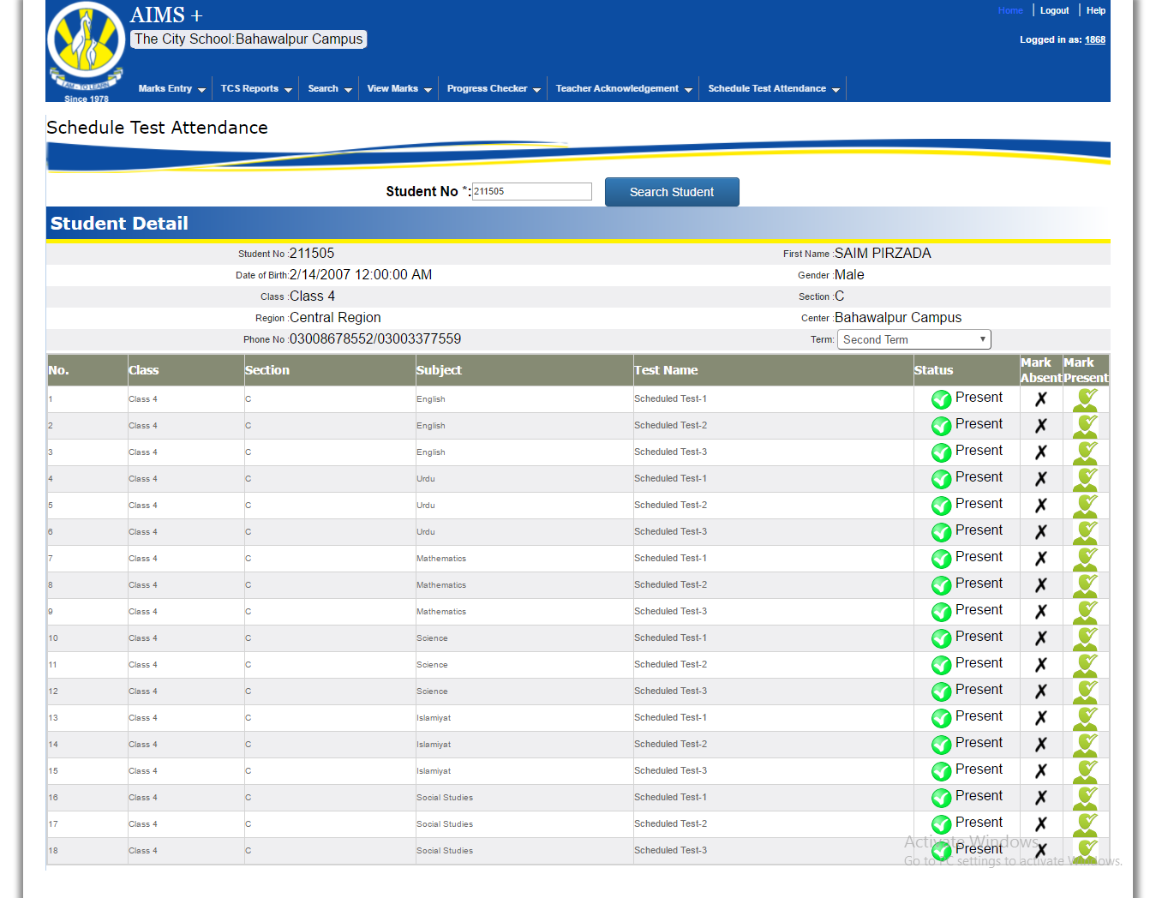

Now after selecting the term teacher can mark absent / Present of student for relevant schedule test.

# Progress Checker

## Progress Checker



(To enter the progress checker marks)

Progress Checker 🡪 Progress Checker

Teacher can mark progress checker marks of relevant assign section wise student.

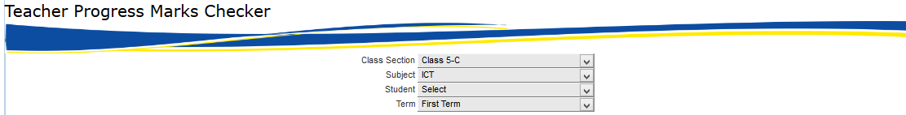

And teacher can select information by following criteria filters

Class-Section🡪Subject🡪Student and Term

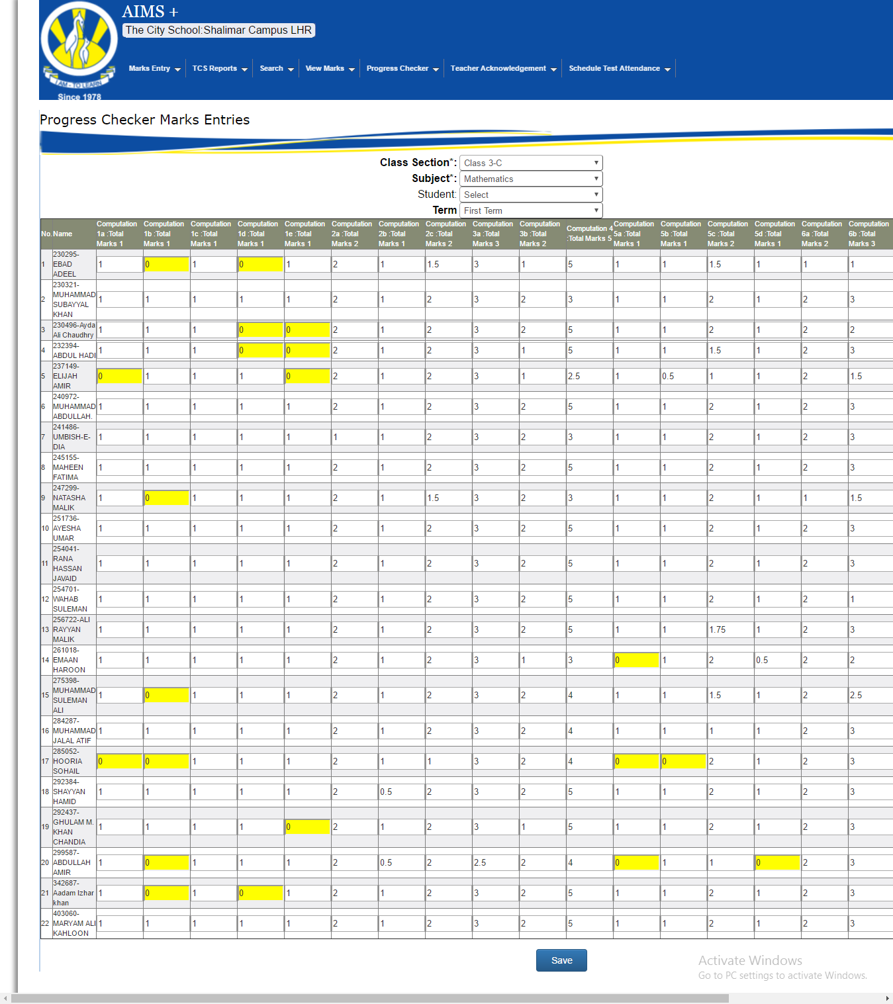

And teacher can easily marks according to Progress Checker Section and Question name and this screen have restriction that teacher can’t enter marks greater then total marks system will show the message box

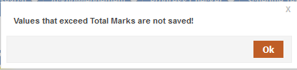

Then greater marks will be highlighted in RED Color like this

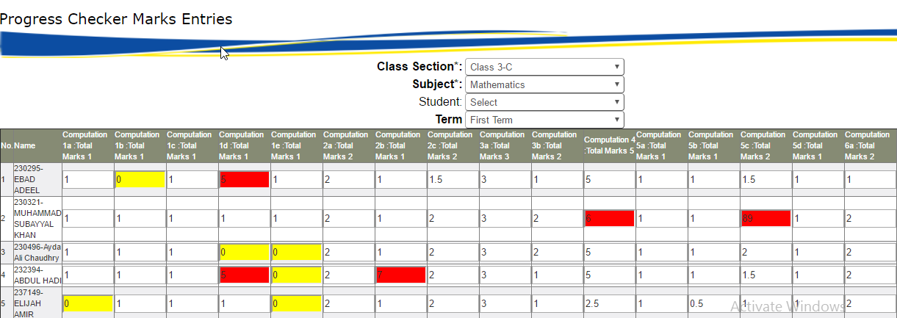

Then teacher can change the marks and save the records.